Ed Venator and Chris Dickey

Lab 10

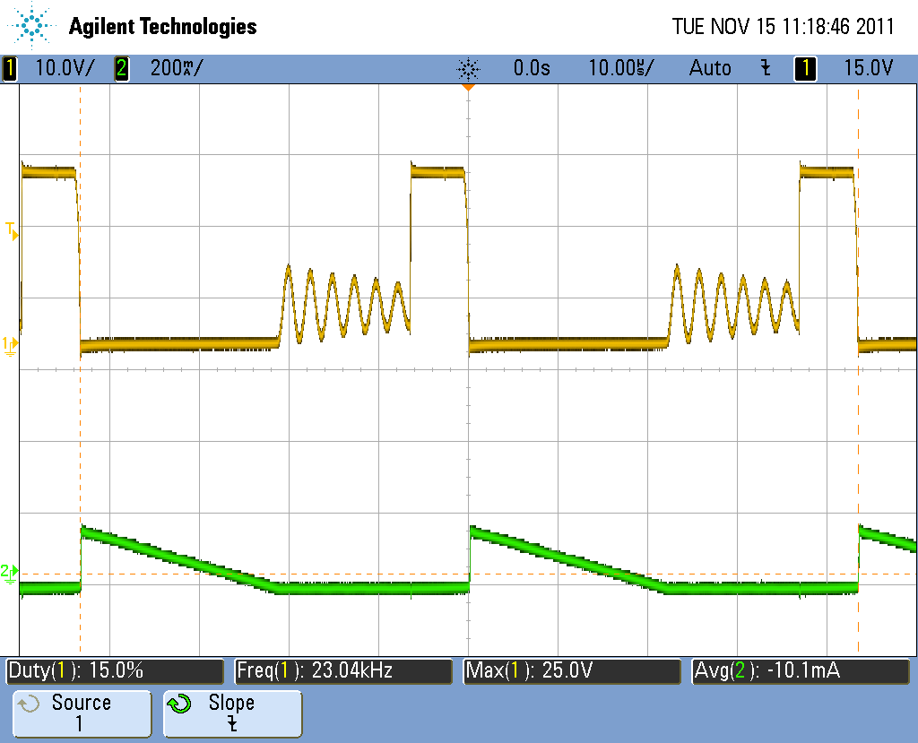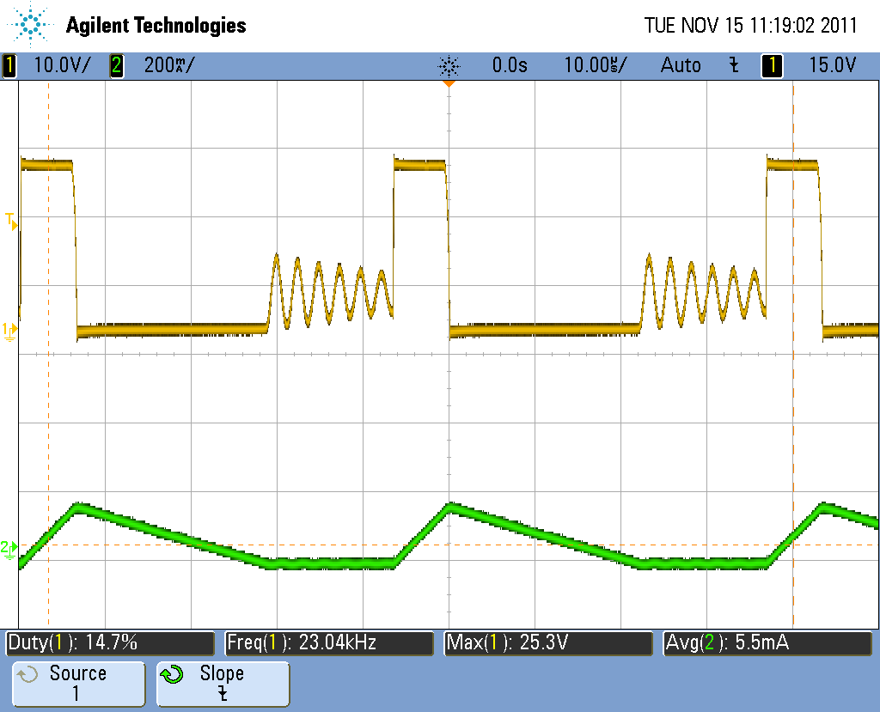

Vdrain and Id (left) and IL(right) (24Vin, 5Vout, 46mA load)

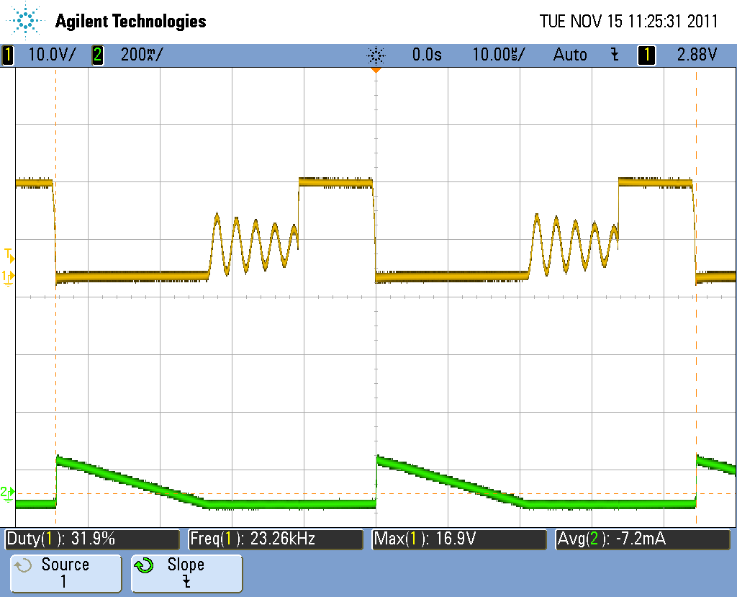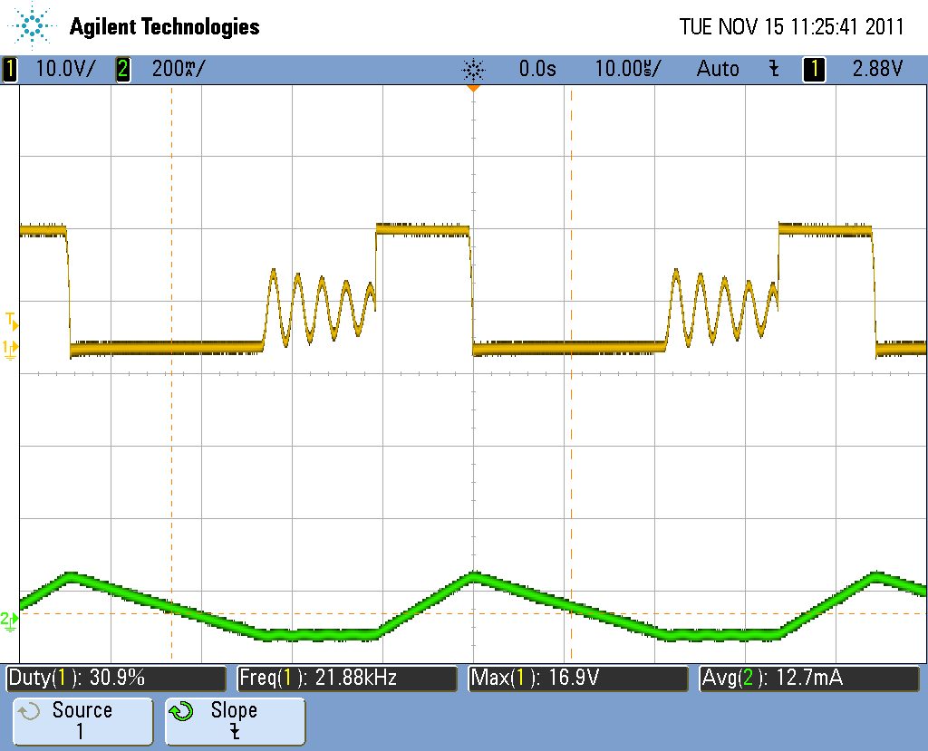

Vdrain and Id (left) and IL(right) (16Vin, 5Vout, 46mA load)

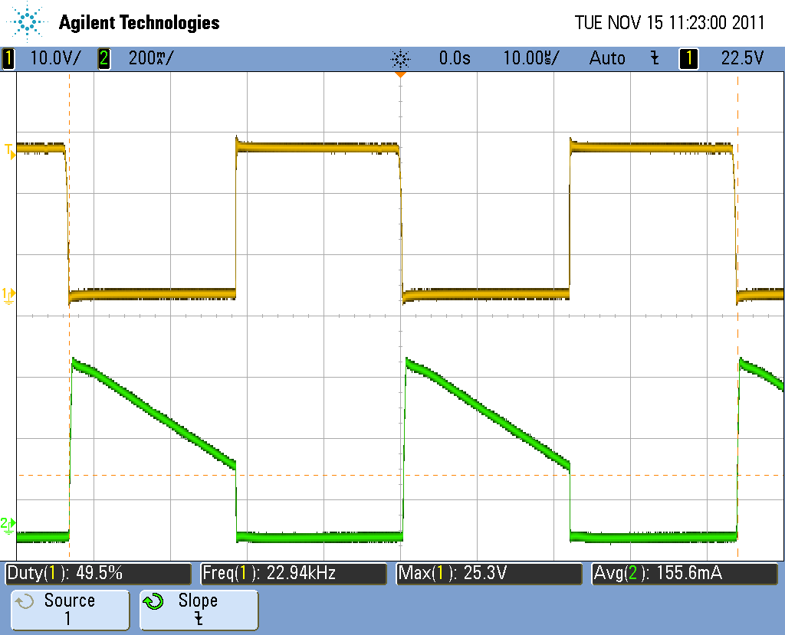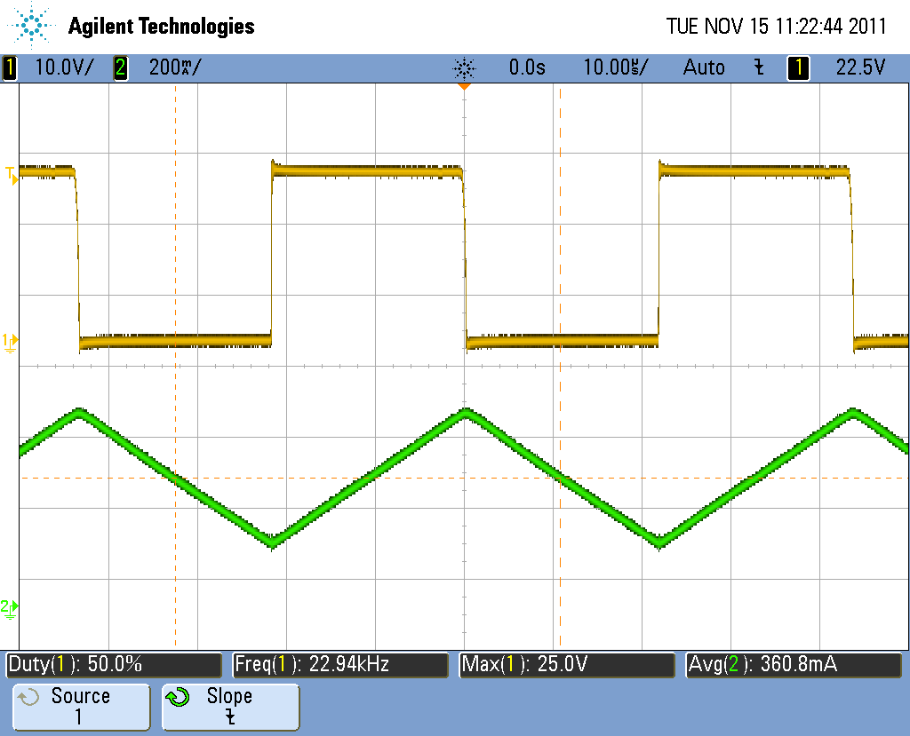

Vdrain and Id (left) and IL(right) (24Vin, 12Vout, 400mA load)

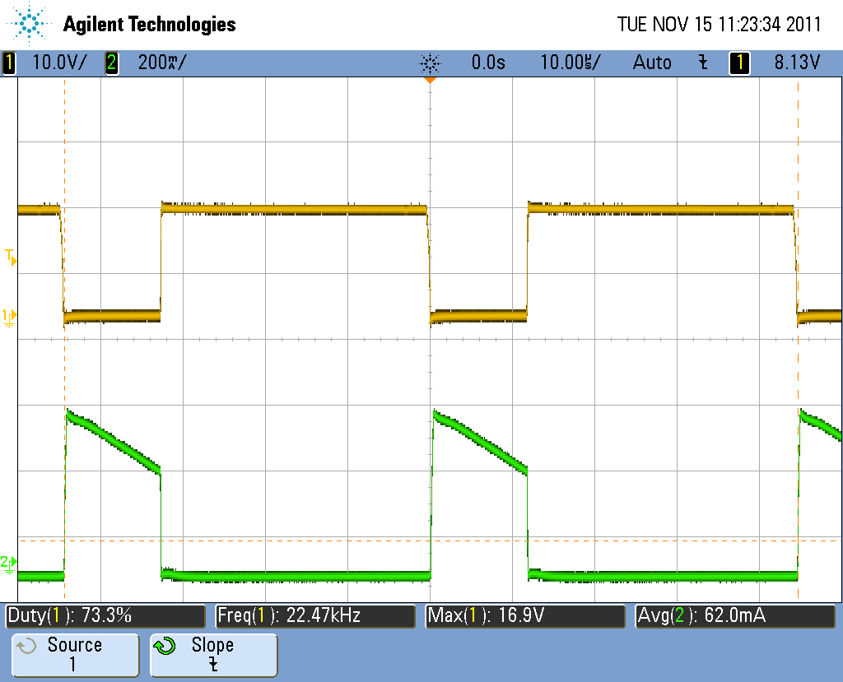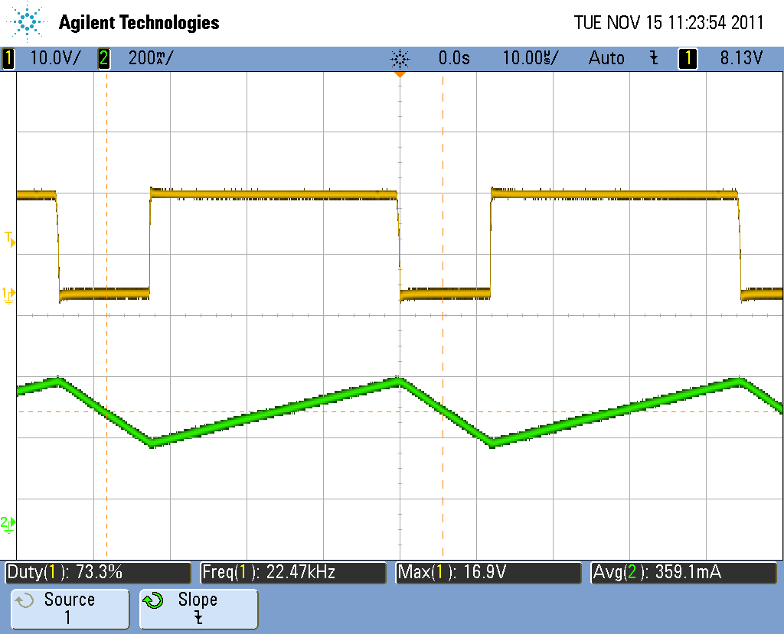

Vdrain and Id(left) and IL(right) (16Vin, 12Vout, 400mA load)

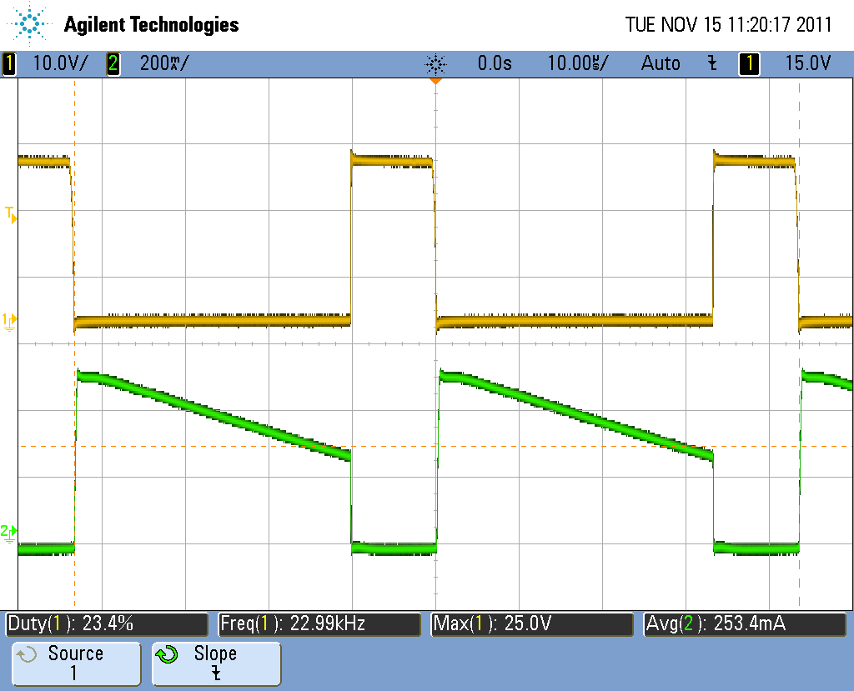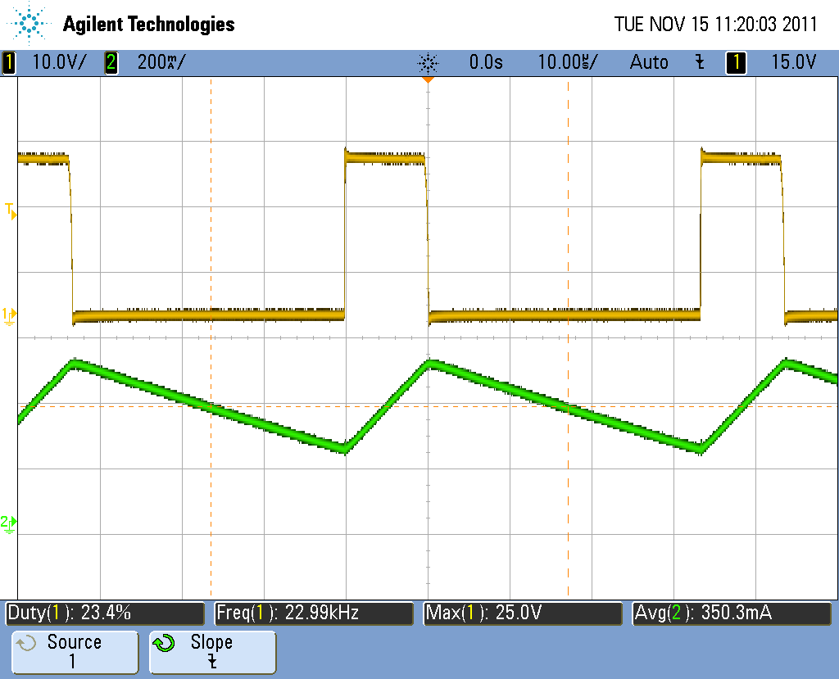

Vdrain and Id (left) and IL(right) (24Vin, 5Vout, 400mA load)

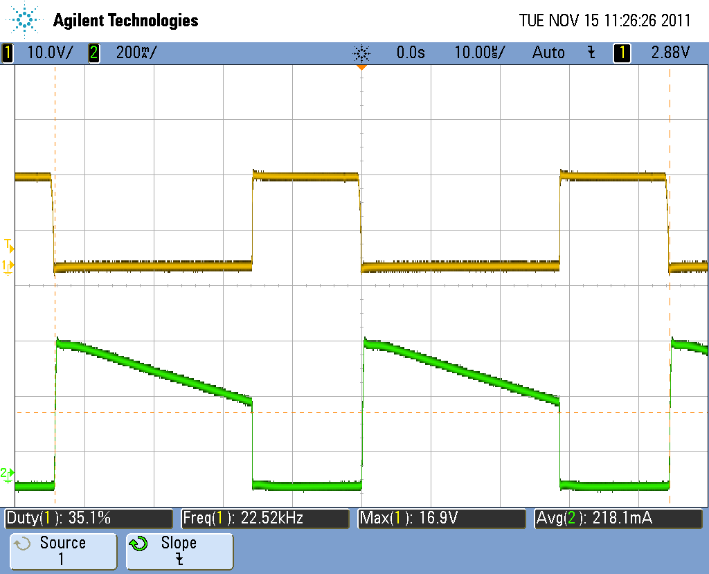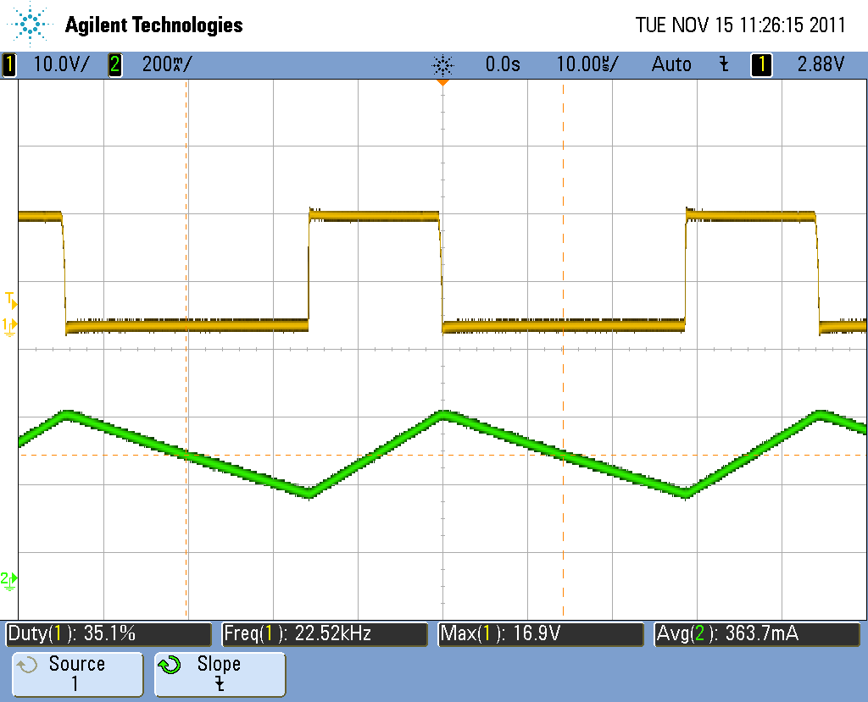

Vdrain and Id (left) and IL(right) (16Vin, 5Vout, 400mA load)

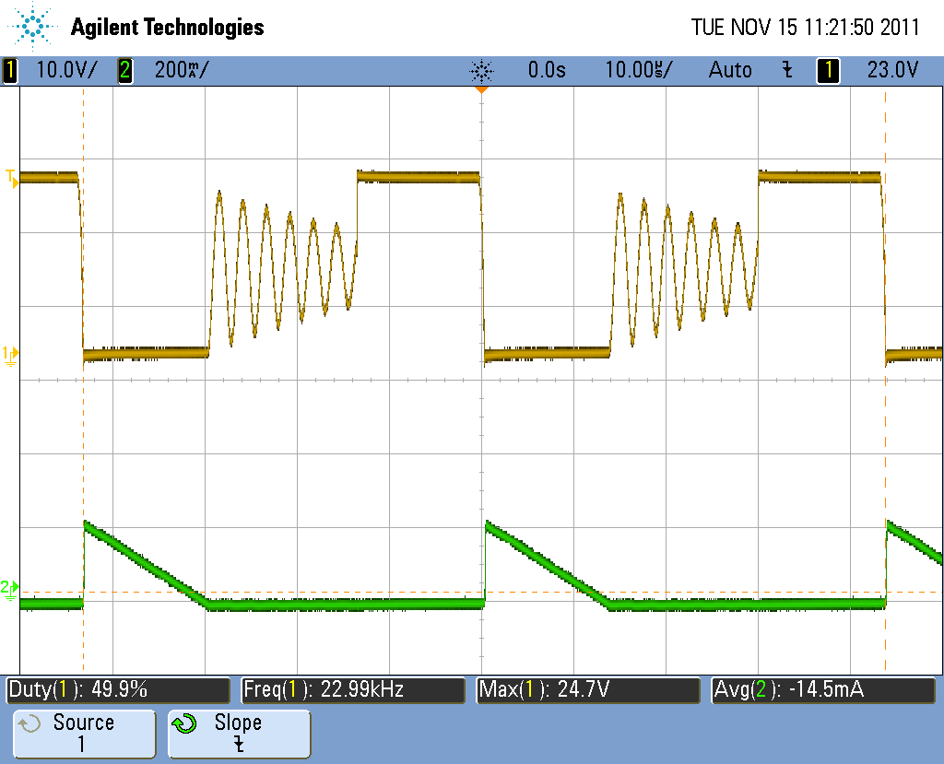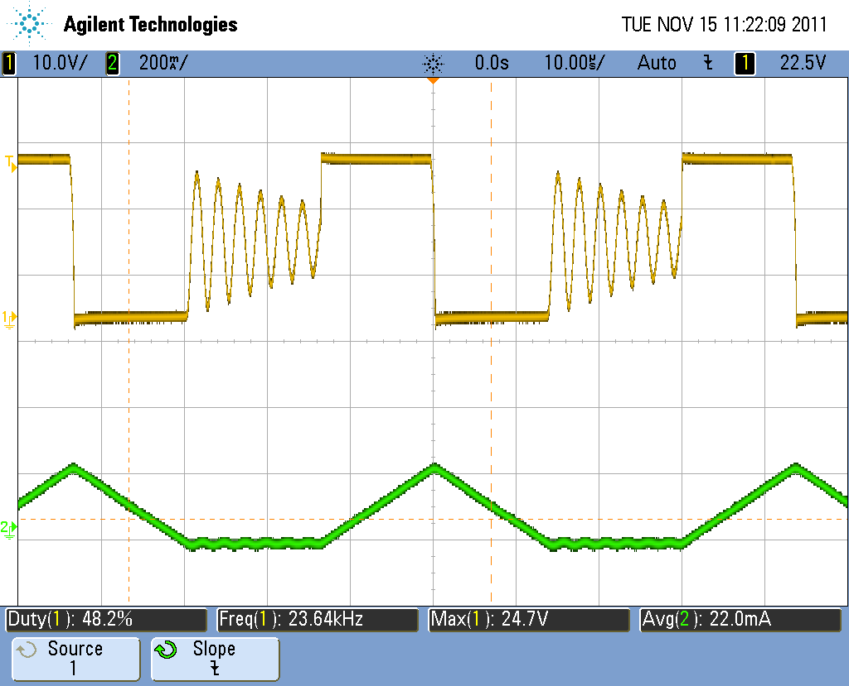

Vdrain and Id (left) and IL(right) (24Vin, 12Vout, 50mA load)

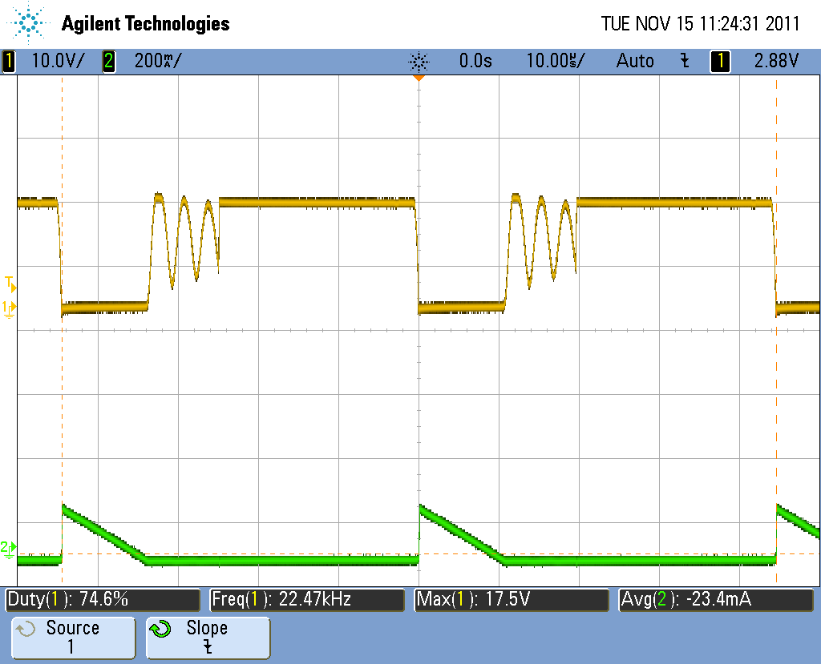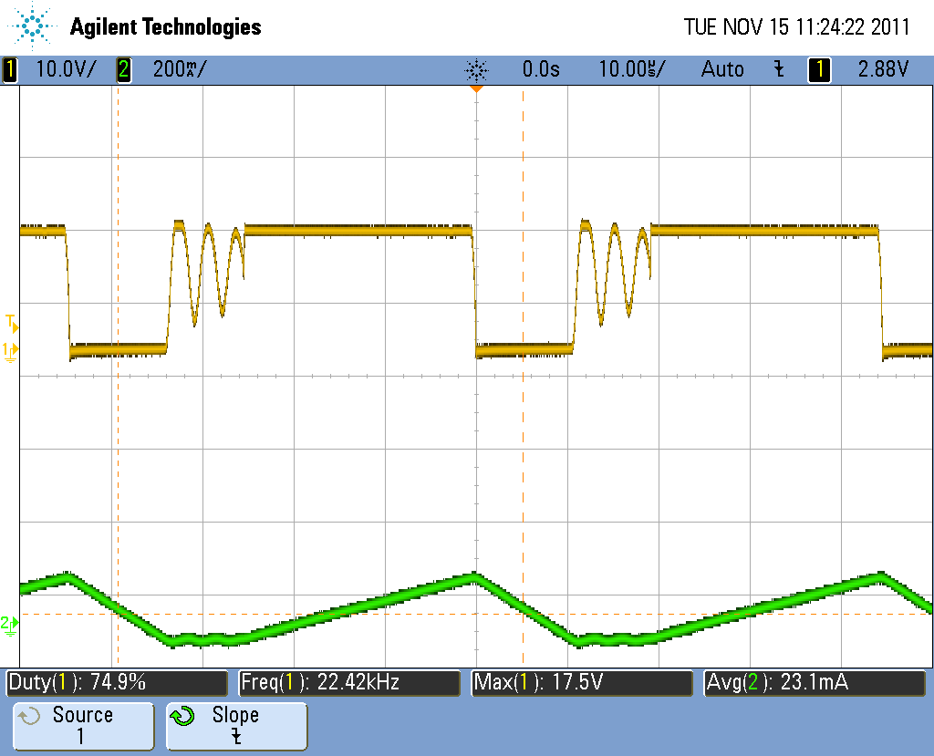

Vdrain and Id (left) and IL(right) (16Vin, 12Vout, 50mA load)